This message was originally intended for my old teacher: Hey Brian. So it looks like my Computer Science course is no longer available, nor my private correspondence. There is a reason I did not pay any of the fees. It's actually being explained in a research paper that I'm starting to write to showcase my abilities. Here is the exact scenario that played out, but I can still that you are still around. All traces of my previous teacher are gone, and she was taking up all of my time. I've addressed this to administration several times, and I am going to released a publication about it in my portfolio. I was wondering if there was ANYTHING you could do about the matter. This is my brainstormed idea:
1. Are math teacher's losing their job to AI? I want to know, because AI is just essentially a large calculator that can also understand English. As long as I can prove that I can do it once for the final essay -- there should be no difference. Am I correct to say this or not? And with all the information on the internet about calculus at university levels, it's something anyone could learn if they are proficient in math. So for me to have you answer my question should make no difference. If the school disagrees, and it's University of The People for example, they can't even prove it by having me hand write it and scan it to them, because I could just plug in your answer, which is essentially what you do with a calculator. Now I'd like to know if math teacher's are losing jobs because of this, and propose it as a very possible idea if in fact they are.
2. Also, back to University of the people. There were a few questions where people copy and pasted the exact question and the criteria, and literally words for word gave the SAME answer. I actually did my work -- and failed. The only difference between the answers was a couple of fill in the boxes, like the students name, and the facts they didn't use Chicago style writing, they used APA. I lost so many points for that, and all they did was plug you in. I know this, because I did the same thing to see -- and literally got THE SAME ANSWER as the other two students who both scored 100. When I brought this to the attention of my teacher, she either took what I said as personal attack on her "teaching methods" or me not accepting my low grade (which I was not going to given the evidence). To help with this, I'm using AI as an actual tool, in to which I wrote: It starts with me saying: Answer this university question ___________. Then you supply the answer. Then I provide the answer you provided and say "Rewrite this in my voice please and check to see if any requirements are missing from the question and the formating the teacher wants is present." I could even open up a new instance of you to do that at this point.
I'll then copy and paste the requirements the teacher asked for originally again. You provide a re-written version of your original answer, which I've now told you in mine, and check it for formatting and missing information. I'd like to know how that is ethical, and I'd also very much like to know why my emails continue to go unanswered, because I have asked them to please explain to numerous times (as I was offered a full scholarship, why they keep demanding that I pay them money for failing grades)? It doesn't only reflect poorly on me, but on the GPA of the average students of the university itself.
As for your class, you were more than fair with me -- and I never once had a problem with you. I really do mean that. I had fallen ill to injury, and you actually replied to me. I also have very good ideas that do require a teacher to actually be present for certain parts of teaching. I have a number of effective methods on how to avoid these problems from EVER happening again to or with any student. Also, every single file in that library can be found online at any version of LibGen. You can even have AI explain to you exactly how to obtain these files for free, so this is not saving the cost of a text book, especially if you can direct the AI to read it to you.
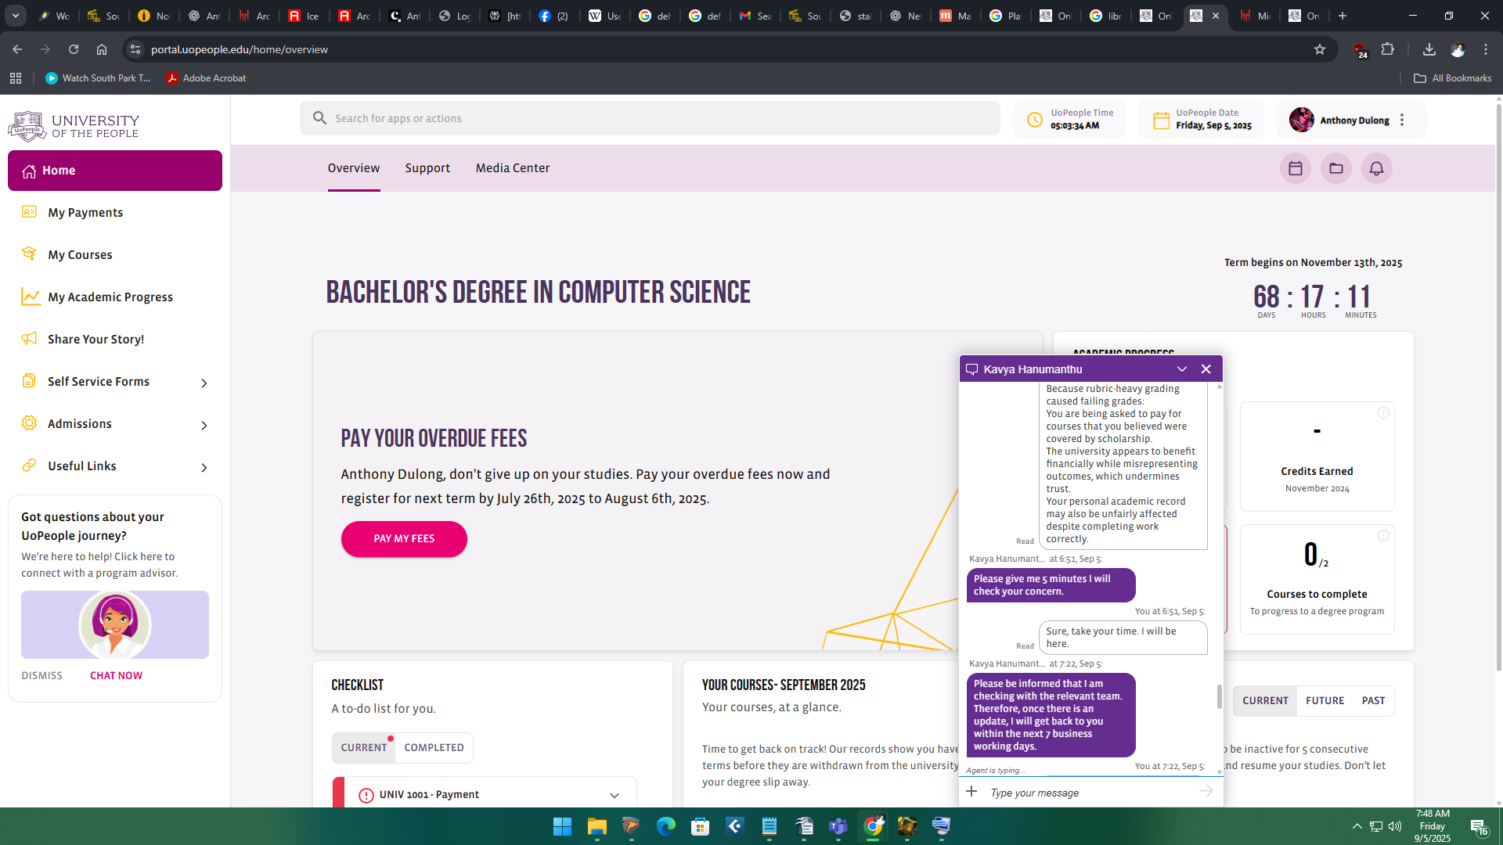

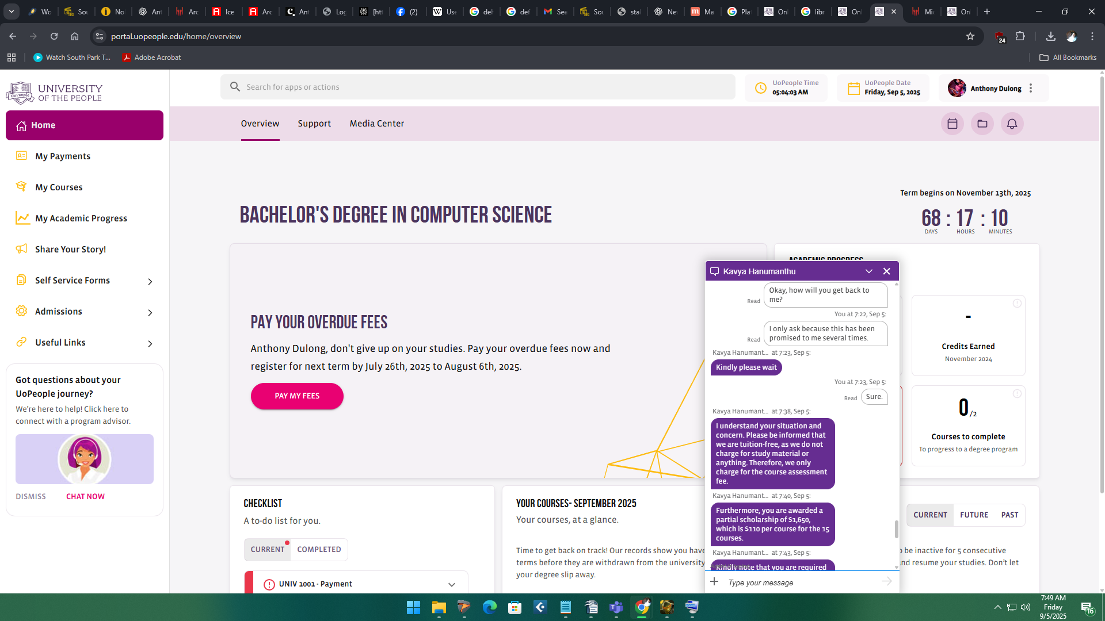

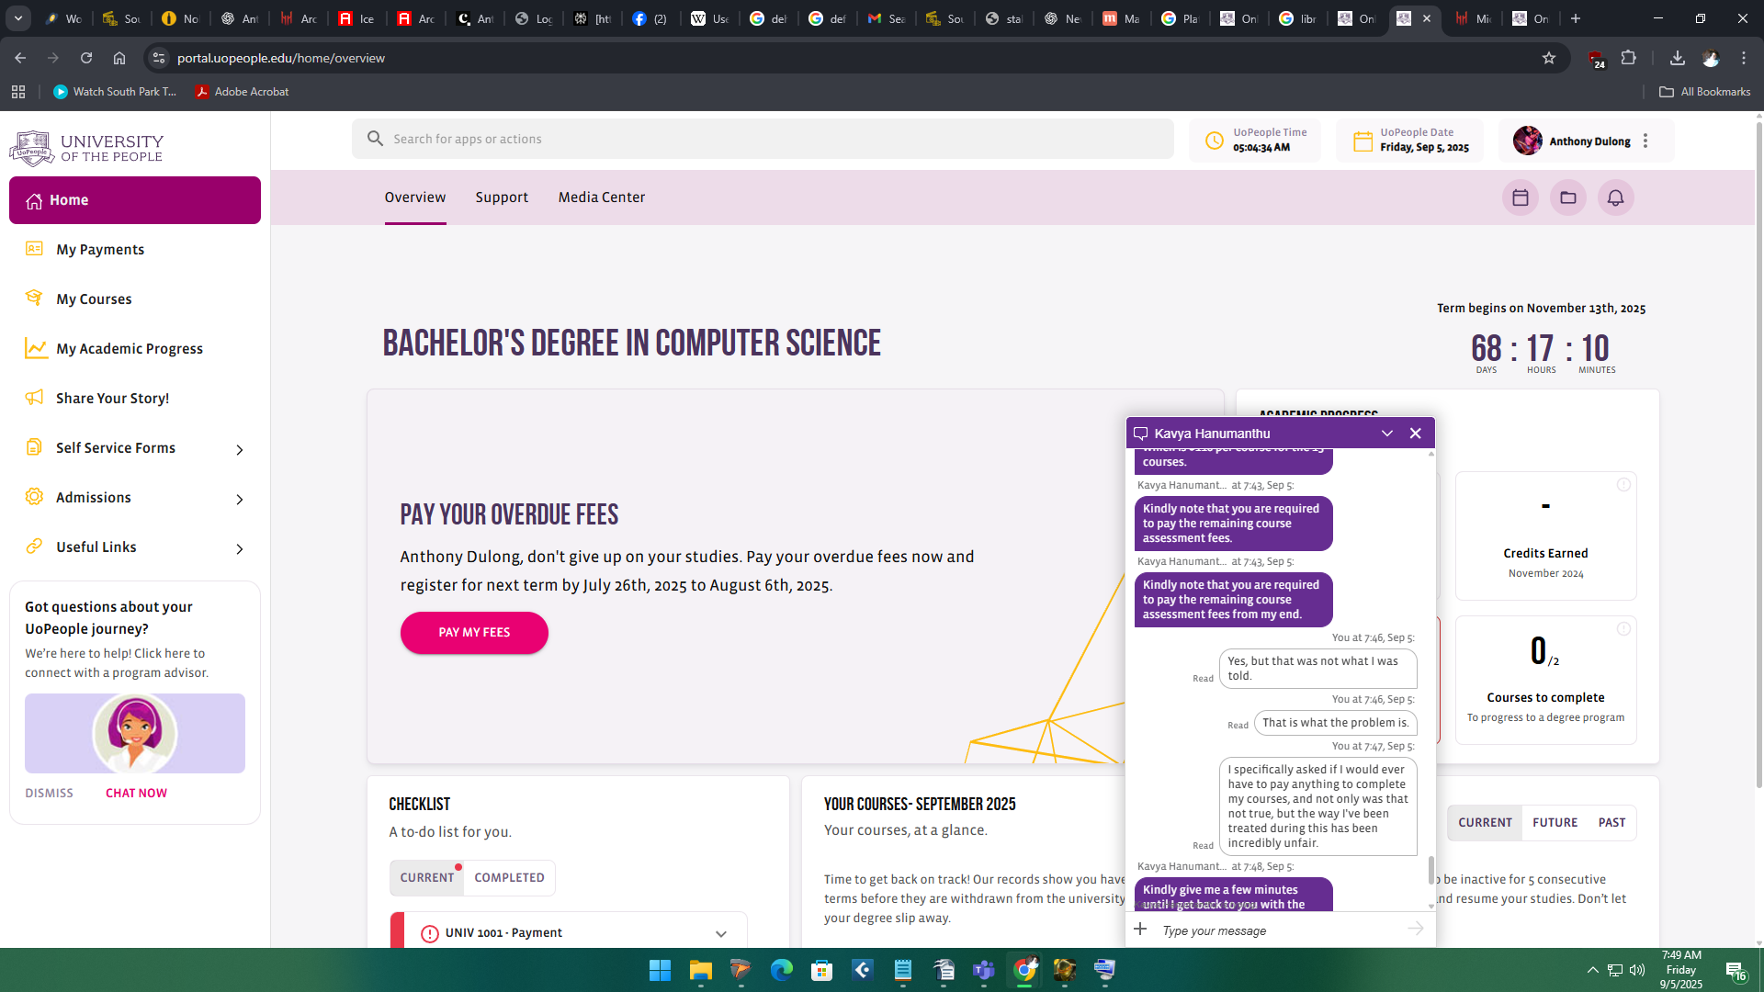

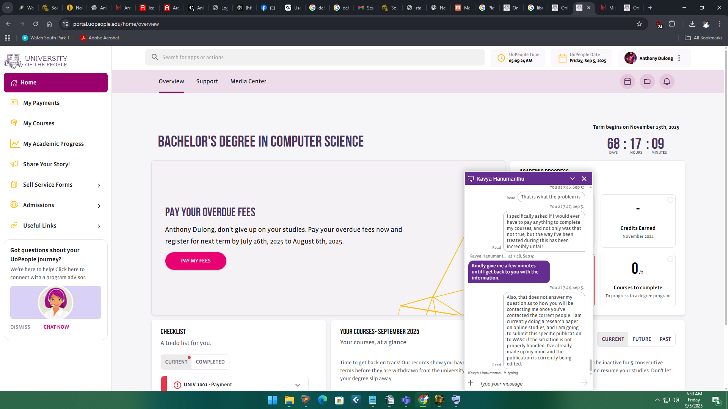

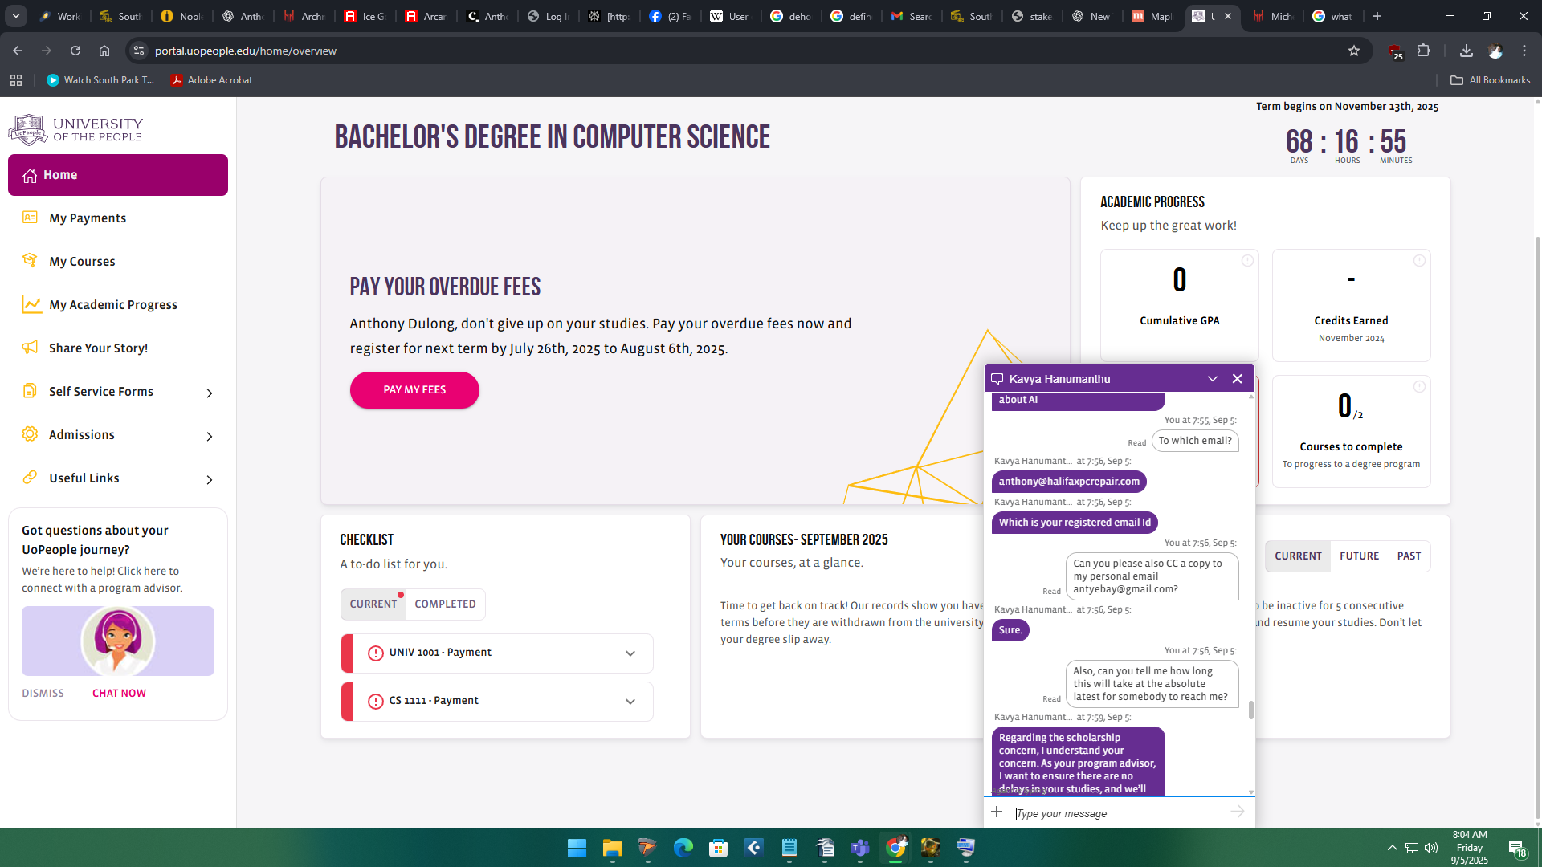

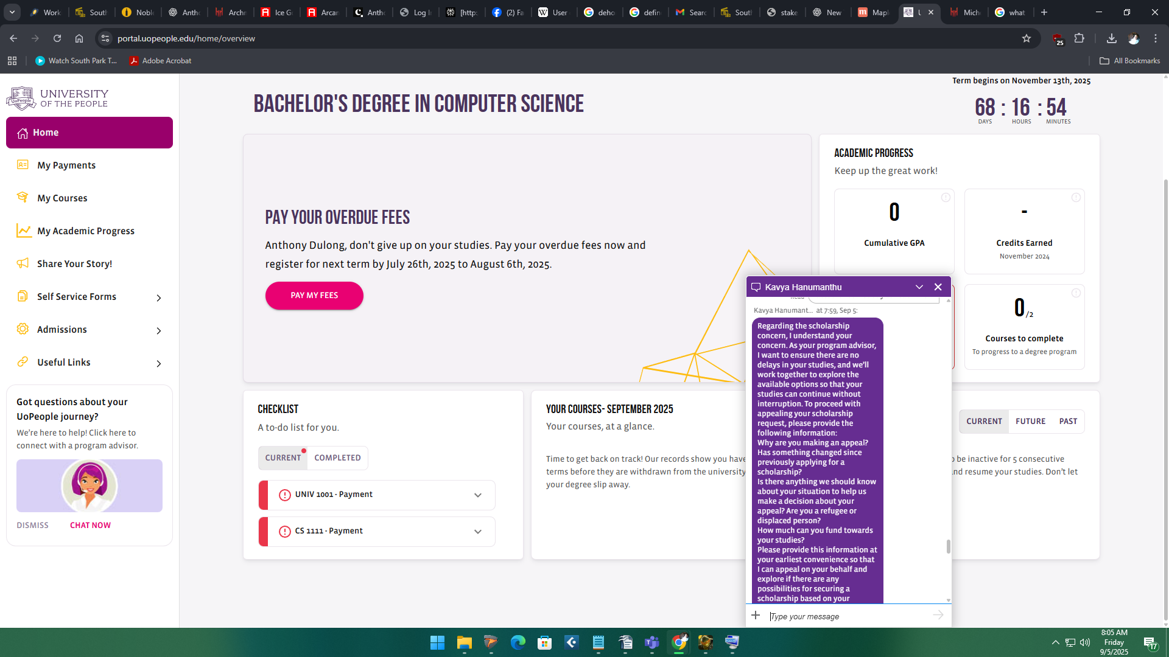

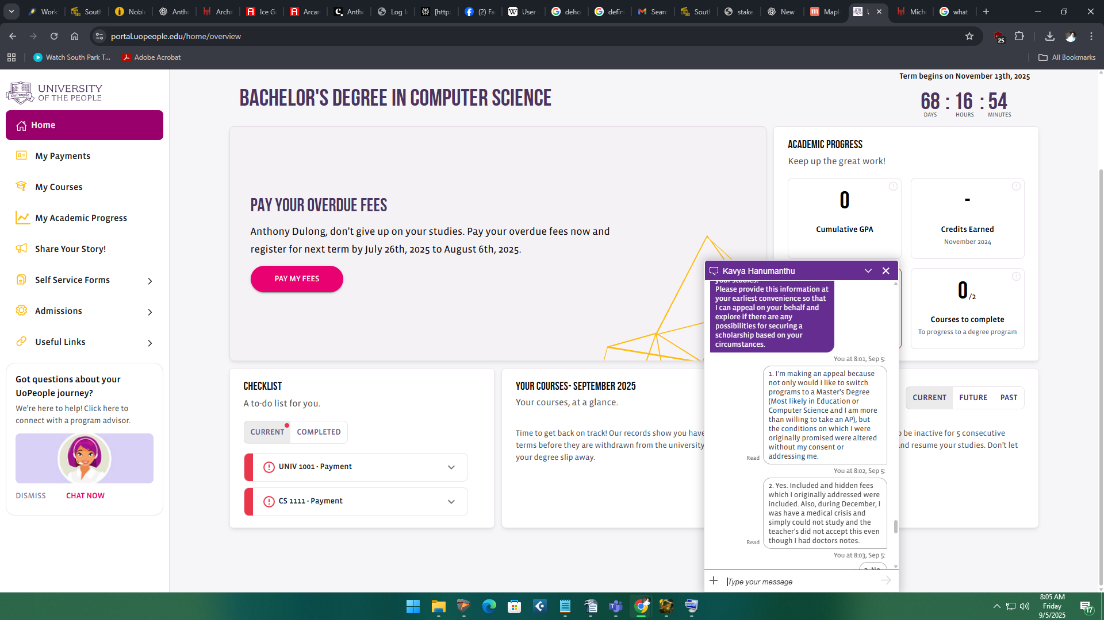

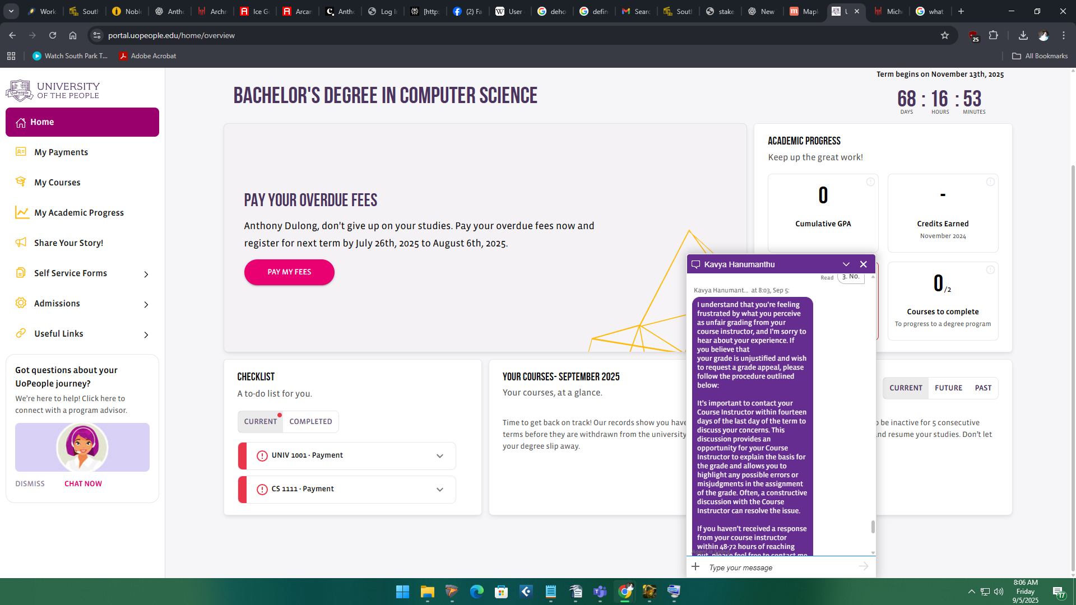

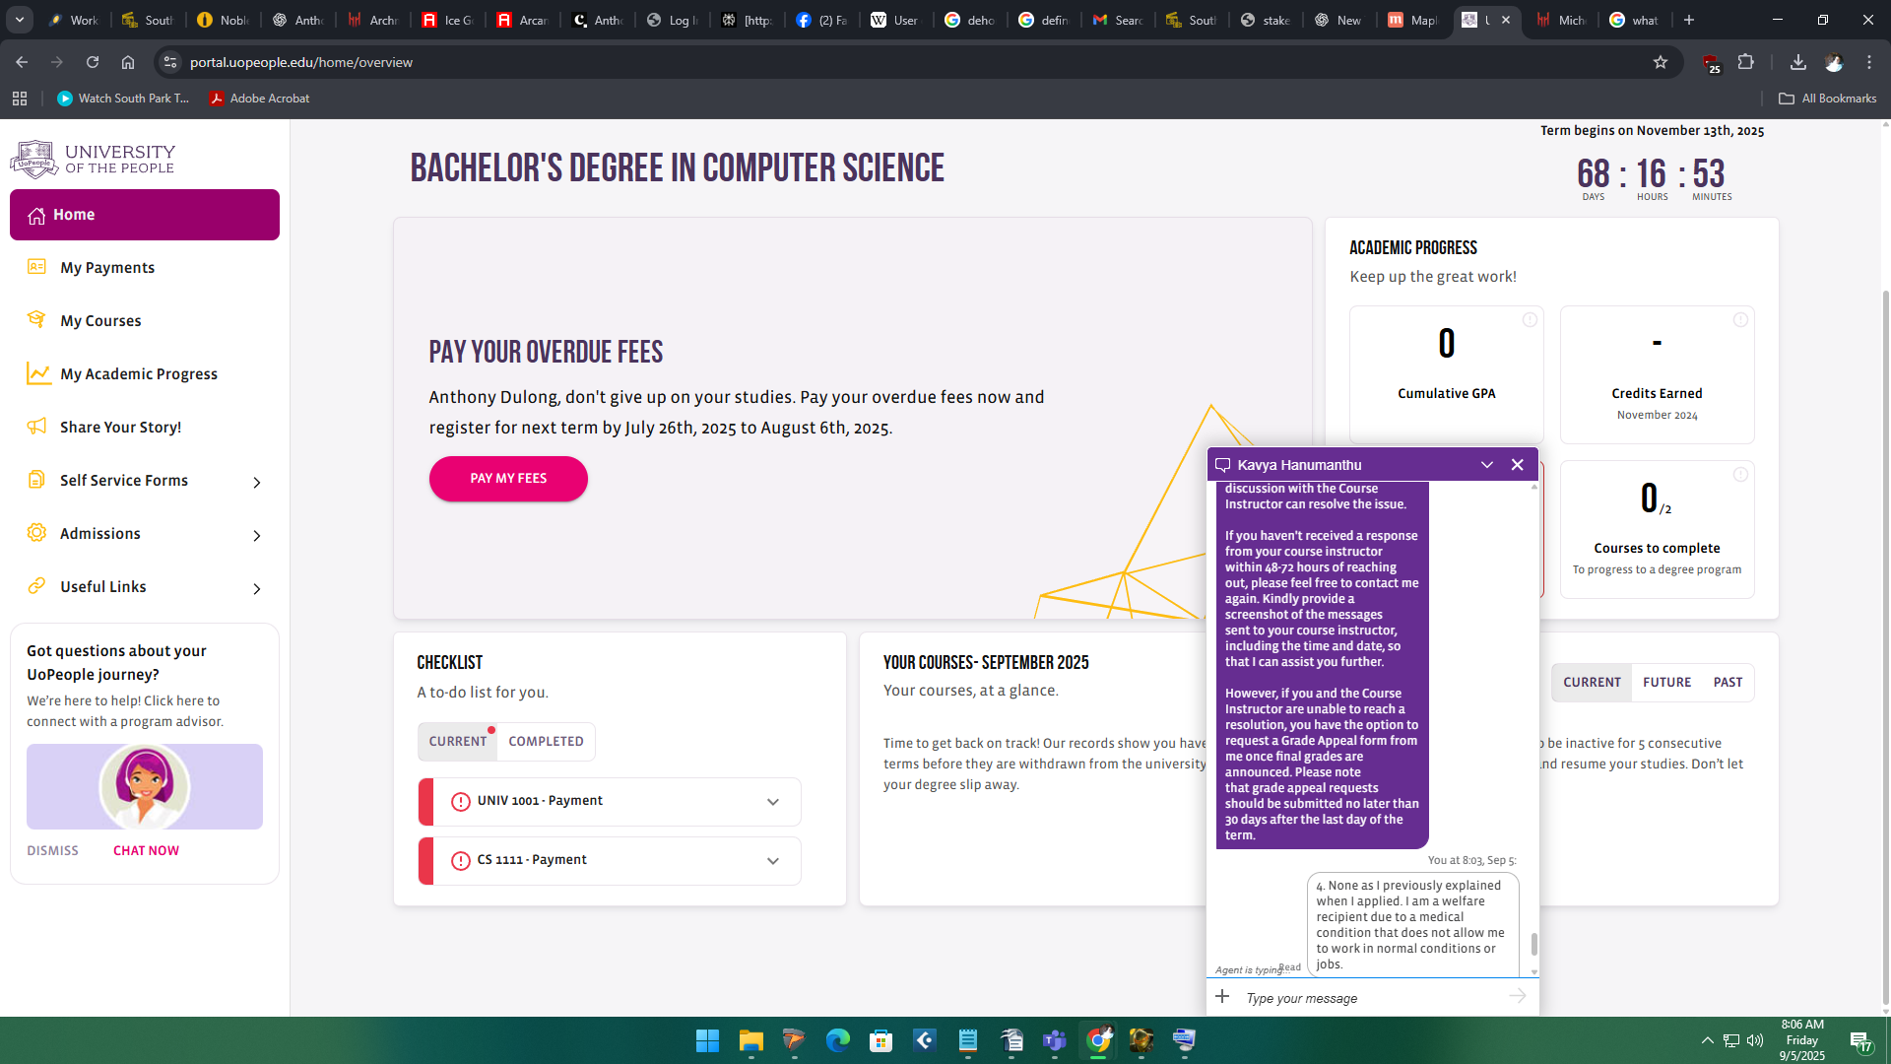

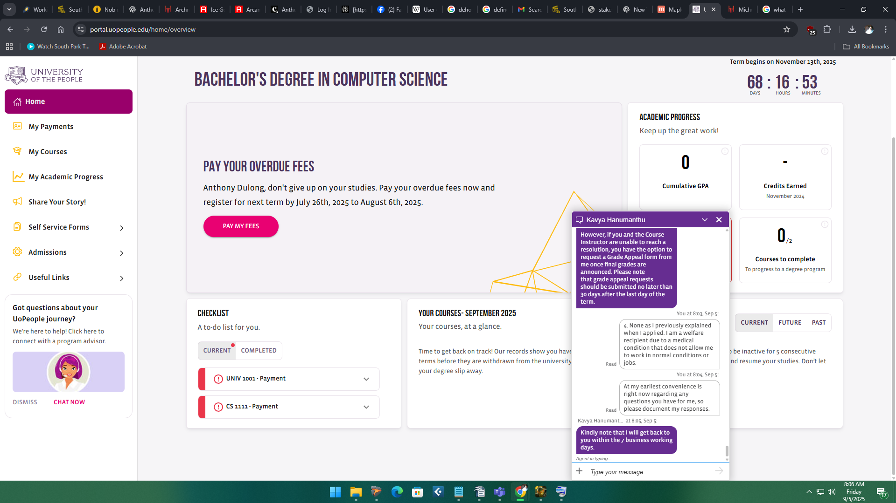

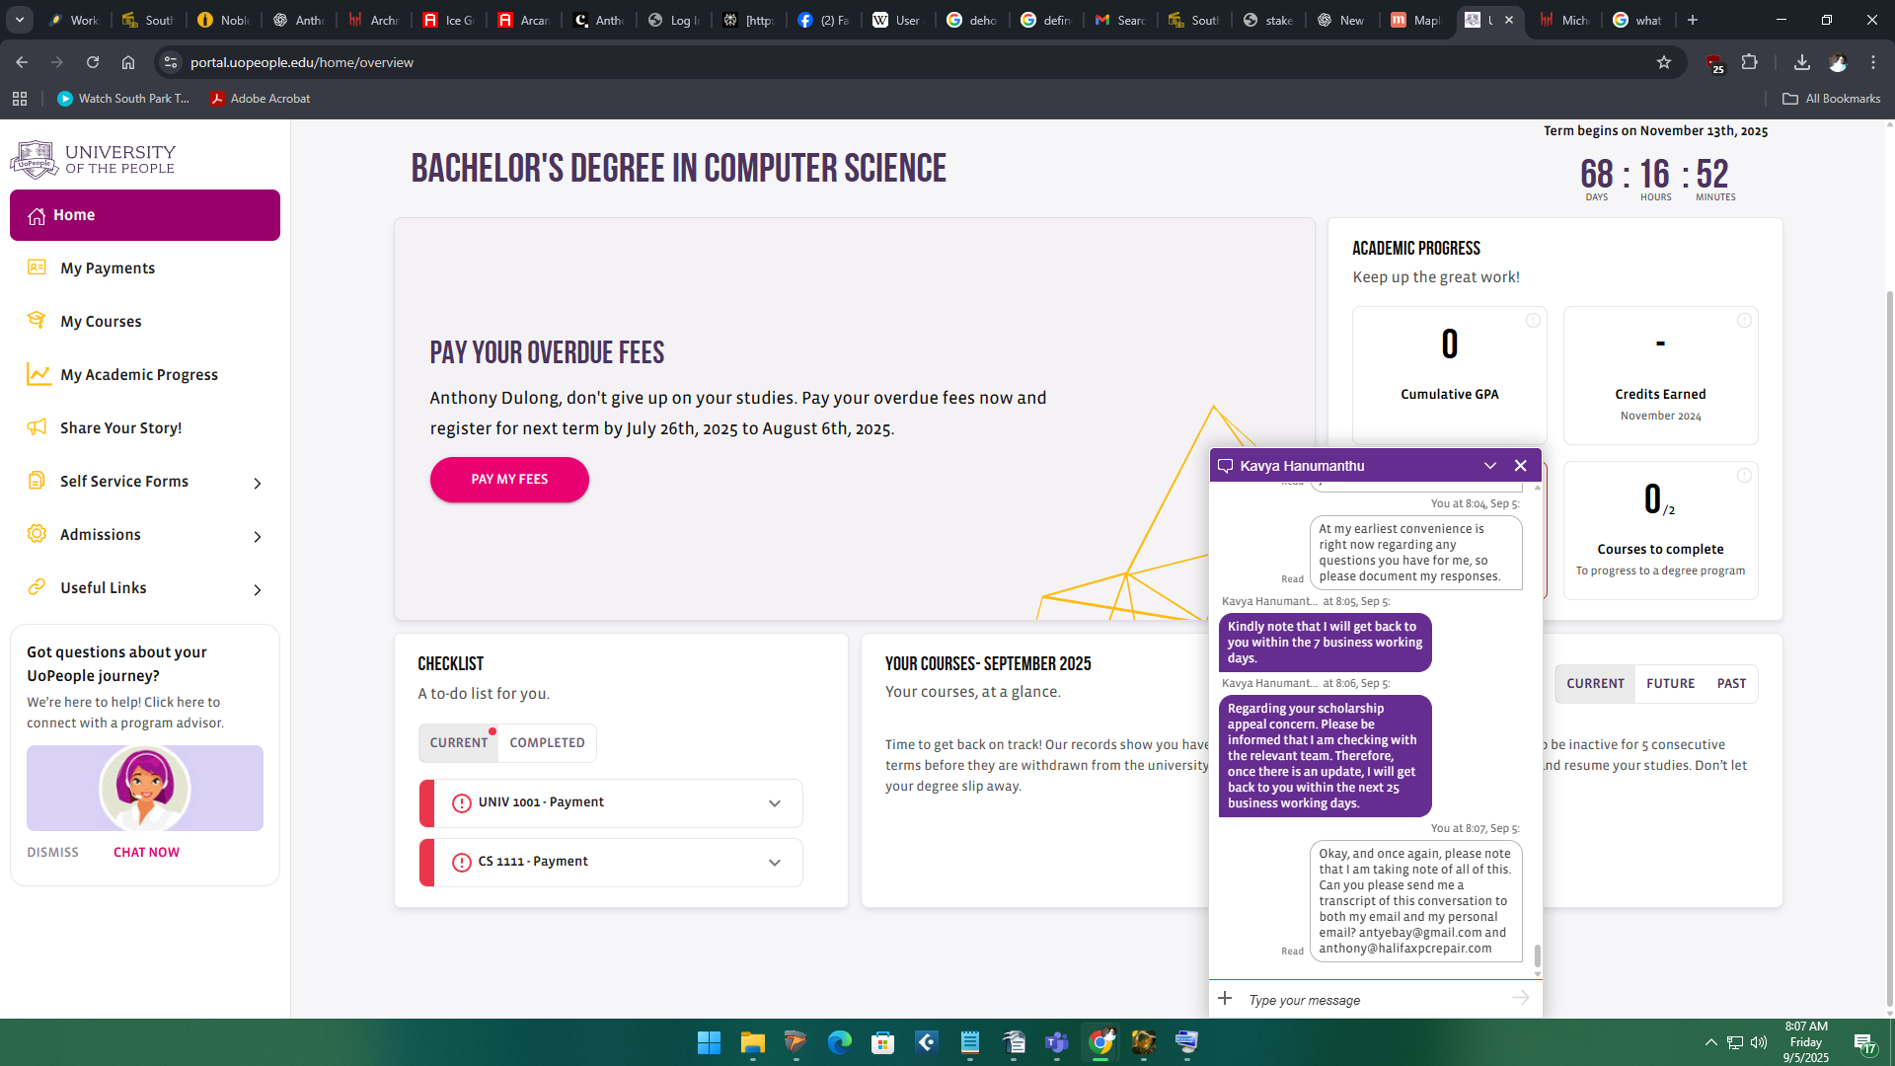

AI: RESPONSE:
1. Scholarship promise vs. hidden fees
- You were promised a full scholarship, which implies no payment for tuition or courses.
- When asked to pay $30 per course after failing grades were assigned, without prior disclosure, this is miscommunication at best, potentially misleading at worst.
- From an ethical standpoint, the university failed to fully disclose the terms of financial obligations.

2. Impact of grading practices
- Because rubric-heavy grading caused failing grades:
  - You are being asked to pay for courses that you believed were covered by scholarship.
  - The university appears to benefit financially while misrepresenting outcomes, which undermines trust.
  - Your personal academic record may also be unfairly affected despite completing work correctly.

3. Implications for your research paper
- You now have two angles for your portfolio piece:
  - AI and grading fairness — how rubric-based grading can penalize original effort and reward mechanical matching.
  - Administrative transparency — how undisclosed or retroactive fees and scholarship mismanagement create systemic inequities.
- Together, these make a strong research case about structural problems in online higher education, with ethical, academic, and financial dimensions.
I'm contacting the school with this message. The first and easiest part is to grade not only on assignments, but to make a MUCH larger part of your grade based on one chance testing. Assignments should comprise a fraction of your grades, and although this does not seem traditional to normal university... neither does sitting on your computer from home and earning a degree. So with advancements in technology, the way that grades are calculated cannot be the same at all. There should be small assignments, with tests between every single one of them, with more than browser look down. Your hands should be visible during, and a webcam should be required. There is a massive problem in cheating eliminated in one swoop. I think I should propose that in my research paper as a possible solution to the ending of these problems; but there is still much more work to do.

